CICD EXPERIMENT-11

NAME- Ishita Bansal

Roll no.- R171218124

Sap id- 500071818

Vagrant init command to create vagranfile

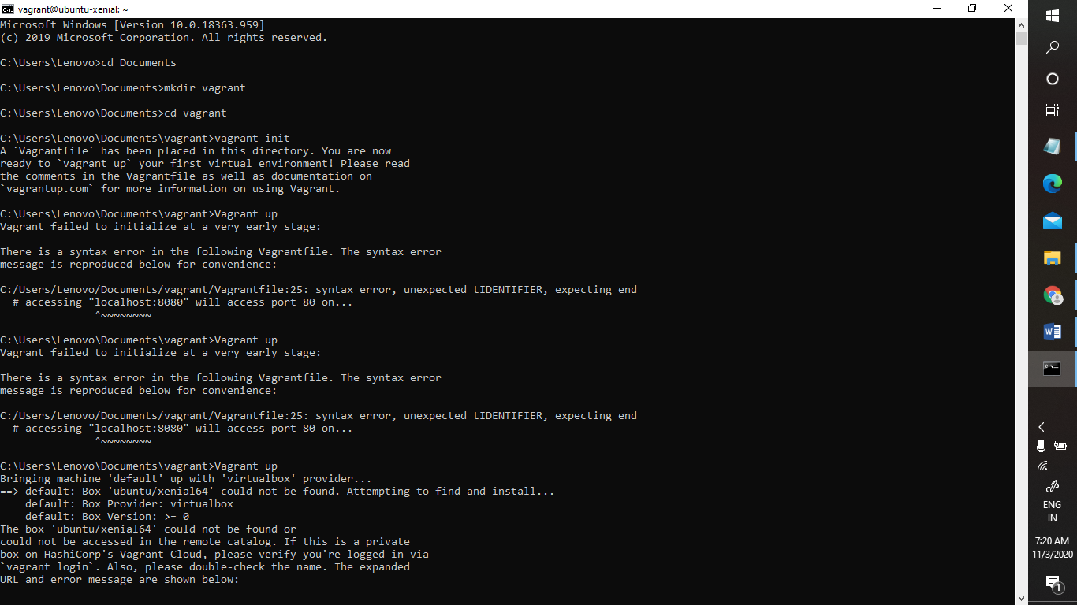

Vagrantfile created and edited-

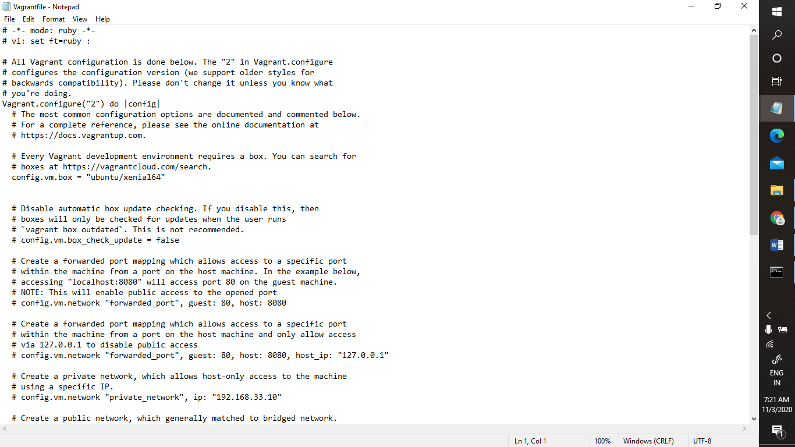

Vagrant up command-

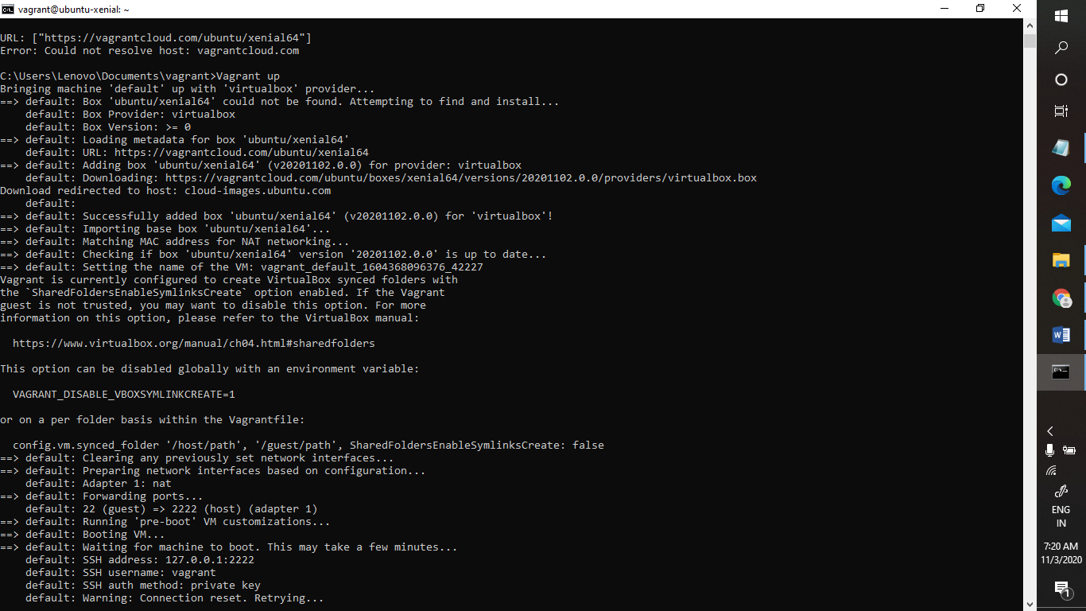

Vagrant ssh command-

